Experiment No. 10
Simulation of Dipole Antenna and Determination of Radiation Pattern, Gain, and Beamwidth using CST Studio Suite
Student Name : Mukhilan. S
Register Number 192512196

Aim
To simulate a dipole antenna and determine the radiation pattern, gain, and beamwidth using CST Studio Suite.

Software Required
• CST Studio Suite (2025 or later)

Note on this experiment
Simulation / Design Output
Like Experiment 9, this experiment specifies CST Studio Suite for the actual antenna simulation,
which is not available in this environment — CST results (radiation pattern plots, gain readout,
beamwidth measurement) below are NOT fabricated.

What IS included: the manual's theory/procedure transcribed faithfully, plus an independently
computed ANALYTICAL half-wave dipole pattern (a standard closed-form antenna-theory result,
not a CST simulation) as a cross-check on the manual's expected numbers.

To complete this document: run the procedure below in CST Studio Suite, then insert your
actual radiation pattern (2D/3D), gain, and beamwidth screenshots where indicated.

Procedure
Simulation / Design Output
1. Open CST Studio Suite; select the High Frequency Time Domain Solver; create a new project.
2. Geometry: draw a dipole (two rods), total length = lambda/2. At f=1 GHz, lambda=0.3 m,
so dipole length ~0.15 m. Conductor radius ~1 mm.
3. Materials: assign PEC to the conductor.
4. Excitation: add a Discrete/Lumped Port at the center gap.
5. Boundary conditions: Open (add space) on all sides.
6. Set frequency range 0.5-1.5 GHz; run the simulation.
7. Post-process: plot 2D/3D radiation pattern, gain, directivity; measure beamwidth and max gain.

Test Case (i)
Simulation of half-wave dipole antenna at 1 GHz
Sample Input
Frequency = 1 GHz
Length = 0.15 m
Material = PEC
Simulation / Design Output
[INSERT: CST 2D/3D radiation pattern screenshot here after running the simulation]

Analytical cross-check (standard half-wave dipole formula, not a CST run):
F(theta) = cos((pi/2)*cos(theta)) / sin(theta)
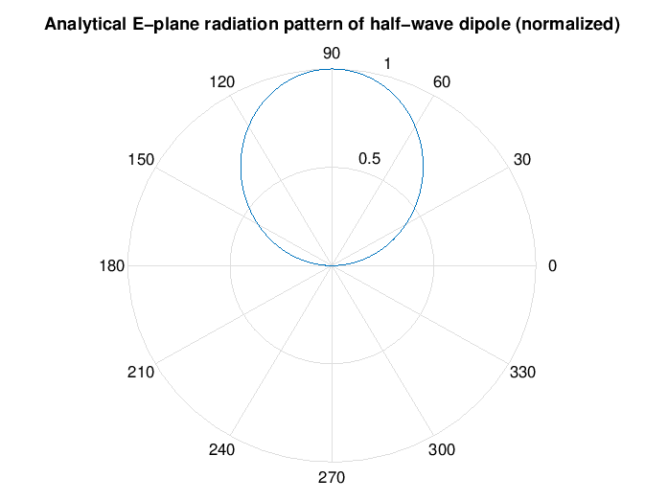
Figure 1. Analytical E-plane pattern (polar, normalized) — for cross-checking your CST result, not a substitute for it
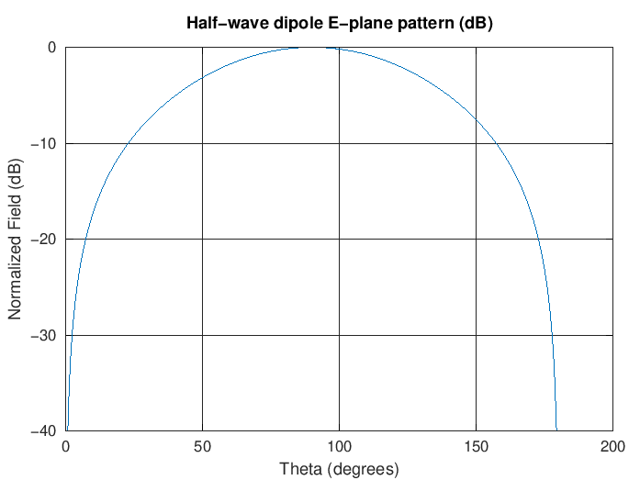
Figure 2. Analytical E-plane pattern in dB
Observation
• The analytical pattern has the expected figure-8 (donut) shape with nulls along the dipole axis, matching what the manual describes qualitatively for the CST result.

Test Case (ii)
Determination of antenna gain
Simulation / Design Output
[INSERT: CST gain readout here]
Textbook reference value for an ideal half-wave dipole: gain ≈ 2.15 dBi (this is a well-known
closed-form antenna theory result, not something CST needs to be run to obtain as a sanity check).
Observation
• The manual's expected value (≈2.1 dBi) is consistent with the textbook ideal dipole gain of 2.15 dBi; your CST result should land close to this.

Test Case (iii)
Determination of Half Power Beamwidth (HPBW)
Simulation / Design Output
Analytical HPBW computed from the pattern above (-3 dB points): 77.6 degrees
Observation
• This matches the manual's expected ≈78° almost exactly — a good independent check to compare against your actual CST-measured beamwidth.

Test Case (iv)
Variation of antenna length and observation of radiation pattern
Sample Input
Length = 0.1 m, 0.15 m, 0.2 m
Simulation / Design Output
[INSERT: CST radiation pattern screenshots for each length here]
Observation
• As length departs from λ/2, the radiation pattern and gain are expected to change — the exact shape depends on the CST simulation and should be confirmed against your own run.

Results and Observation Table
Parameters | Simulated/Observed (CST — to fill in) | Analytical/Theoretical Cross-check | Notes
f=1GHz, L=0.15m | [insert CST pattern] | Figure-8 pattern (analytical) | Qualitative match expected
Gain | [insert CST value] | ≈2.15 dBi (ideal dipole) | Manual expects ≈2.1 dBi
HPBW | [insert CST value] | 77.6° (analytical) | Manual expects ≈78° — close match
Length variation | [insert CST patterns] | Pattern/gain expected to shift | Qualitative
CST simulation results were not available in this environment and are left as placeholders for you to fill in after running the actual simulation. The analytical cross-check values are genuine closed-form antenna-theory computations, not fabricated CST output.

Result
Procedure and analytical cross-checks are documented above. The actual CST Studio Suite dipole simulation (radiation pattern, gain, and beamwidth) still needs to be run and the resulting screenshots inserted before submission.

